Chengyu Wang, Simeng Pang and Yaowei Guo

**Workshop1**

Clock Dividers

1. The period of the clk_en signal is 1.31 ms. The figure is shown below:

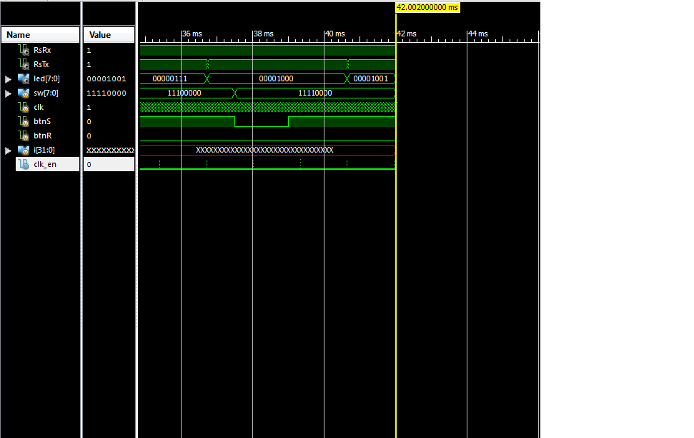

Figure 1: A waveform picture that captures rising edges of clk_en

1. We have P = 1.31ms, and T = 10ns.
$$D=\frac{T}{P}*100\%=\frac{10ns}{\left(1.31*{10}^{6}\right)ns}*100\%=0.00076\%$$

2. The value of clk_dv signal is 0 when clk_en is high.
3. 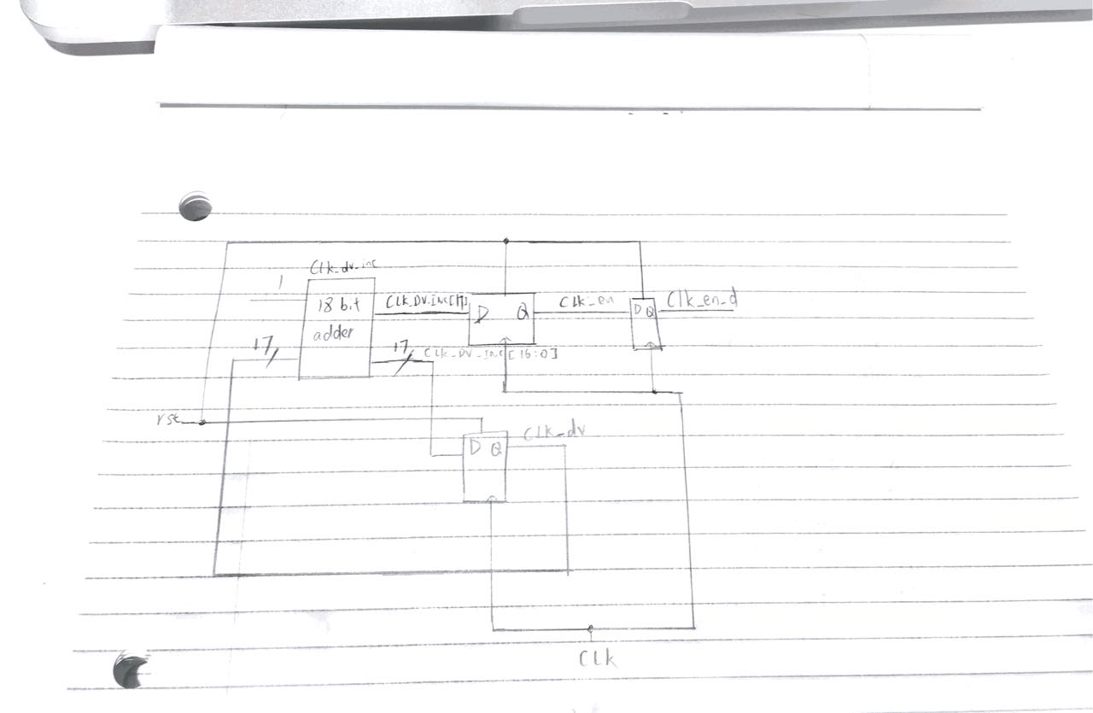

Figure 2: Diagrams of clk_dv, clk_en and clk_en_d

Debouncing

1. This expression is used to record whether the button was pressed one cycle ago. The value of step_d cam be changed only when clk_en is 1, and it’s updated in the next cycle since it’s sequential logic. However, in the next cycle, clk_en already becomes 0. So, ~step_d[0] & step_d[1] & clk_en will always be evaluated to 0. clk_en_d is the clk_en signal delayed by one cycle. When clk_en_d is 1, step_d has already been updated, so we can determine whether the button was pressed or not one cycle ago.

1. It will not make the duty cycle 50%. In the old case, the clk_en signal is high for very short an interval because once the clk_dv_inc[17] becomes 1, clk_dv becomes will become 0. Then clk_dv_inc will be reset to 1 and clk_dv_inc[17] becomes 0 again. So, clk_en is 1 every $2^{17}$ cycles. If we use clk_en <= clk_dv[16] instead, clk_en signal will remain 1 for a much longer time because when clk_dv[16] becomes 1, clk_dv_inc won’t be reset immediately. So, clk_en will remain 1 until clk_dv_inc[17] becomes 1. It’s nearly half of the total cycle time. So, the duty cycle will become much larger instead of 50%.

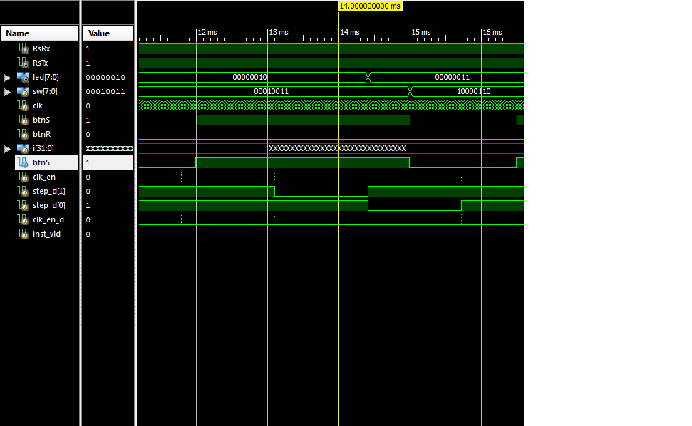

Figure 3: Timing relationship of signals

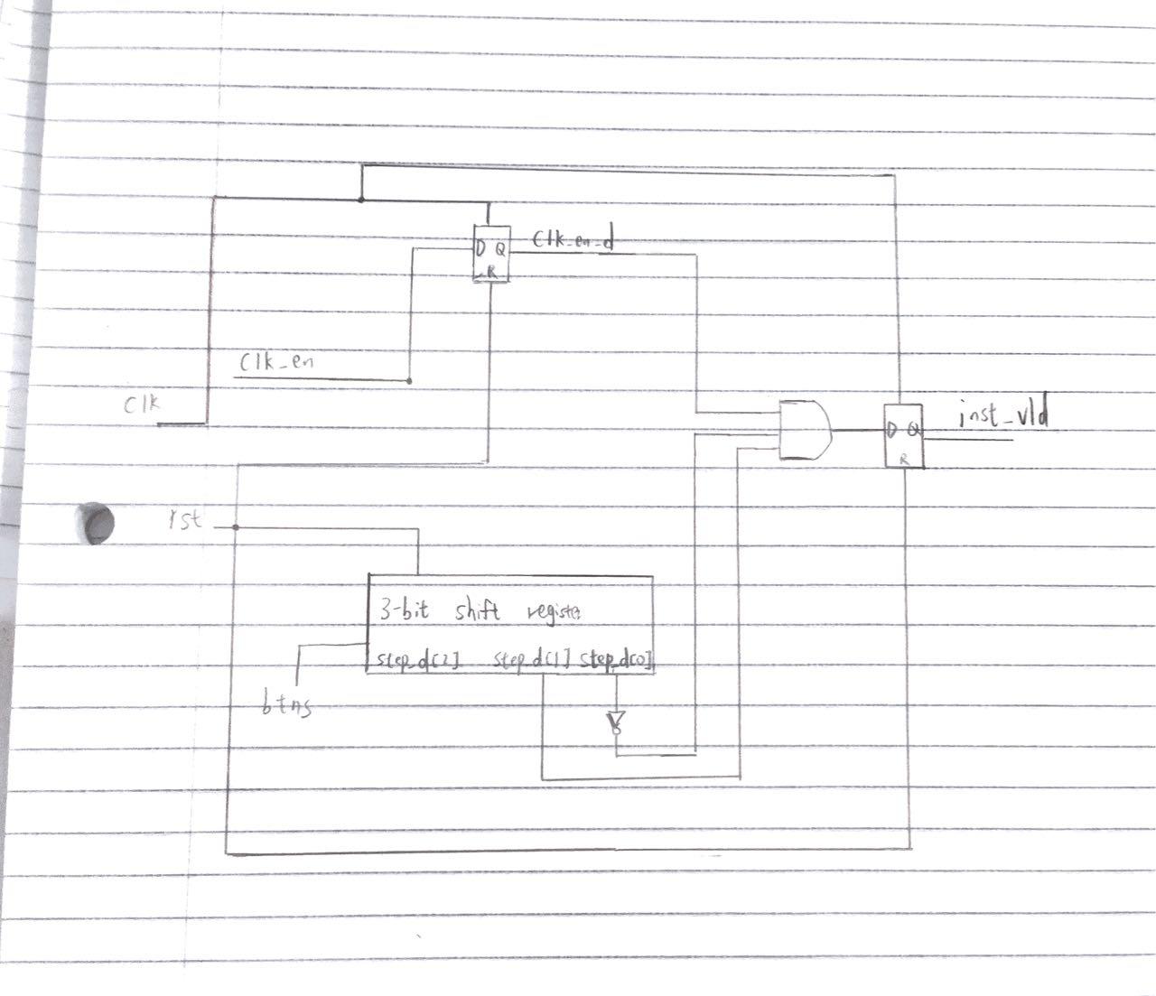

Figure 4:Diagram of signals

Register File:

1. Line 33: rf[i_wsel] <= i_wdata. This is sequential logic. Because this line uses <=, it indicates that this expression uses a non-blocking assignment; the register is written on the positive clock edge.
2. Line 35 and 36:

assign o_data_a = rf[i_sel_a];

assign o_data_b = rf[i_sel_b];

This is combination logic. We can use multiplexers to manually implement.

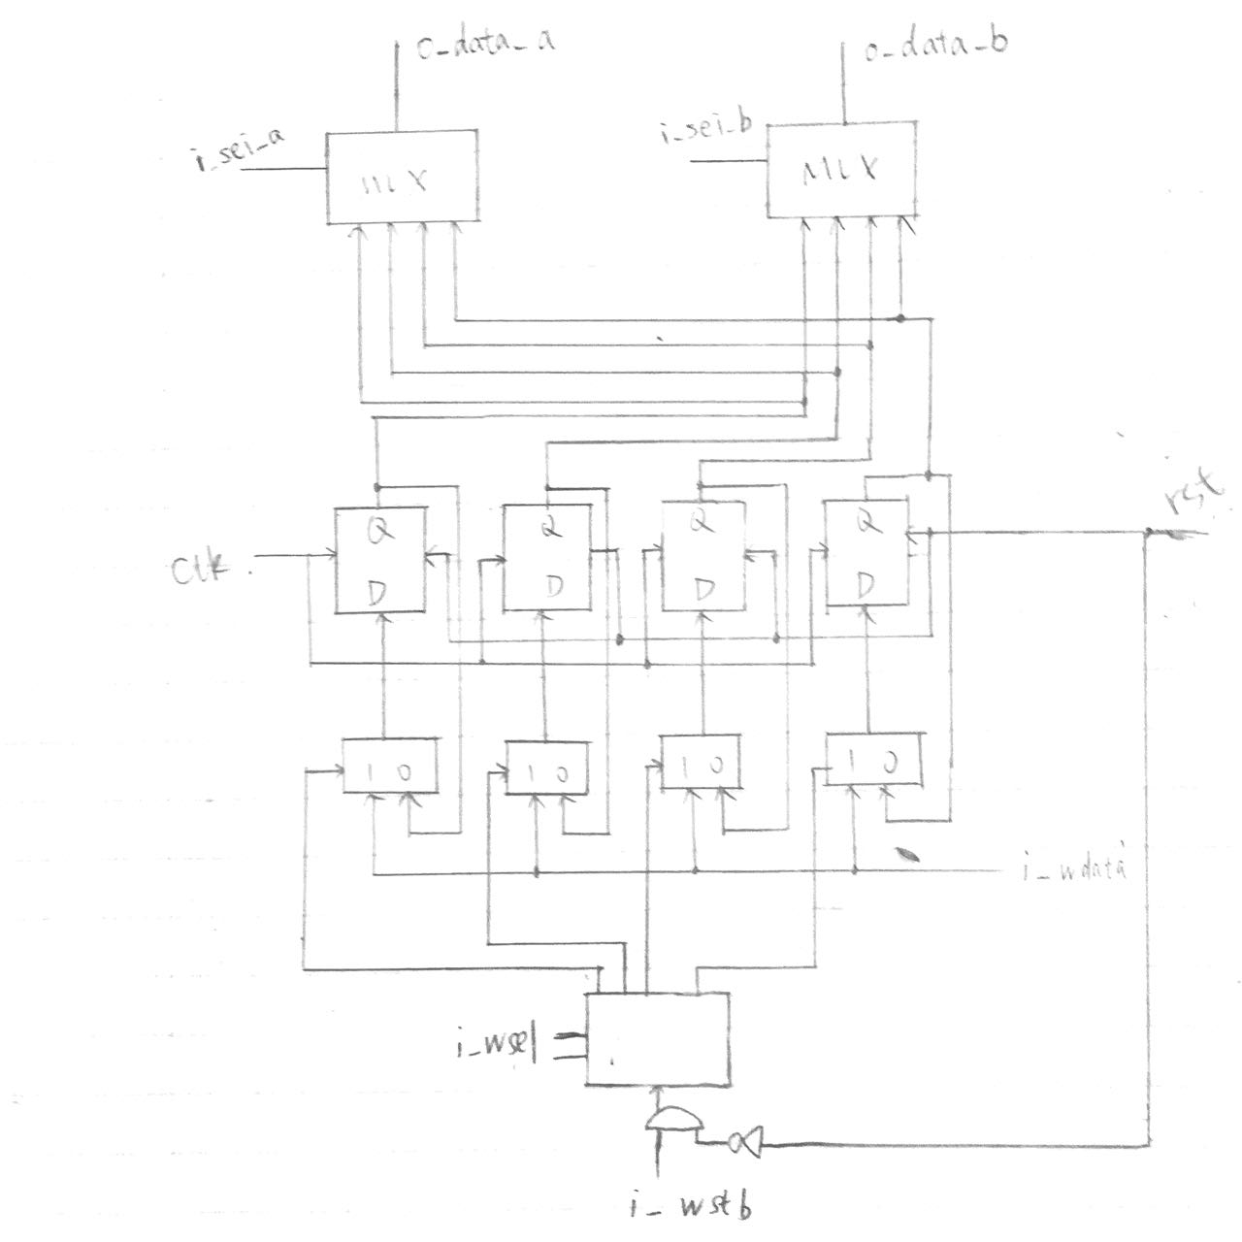

Figure 5: Circuit diagram of register files

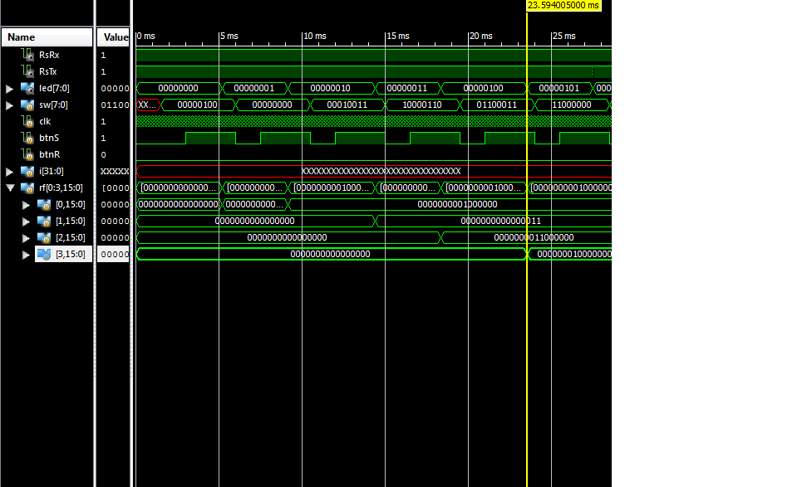

Figure 6: Waveform of the first time register 3 is written with a non-zero value